République française - Ministère de l’Education nationale
Commission nationale du DELF et du DALF

Fiche Inscription
DELF TP
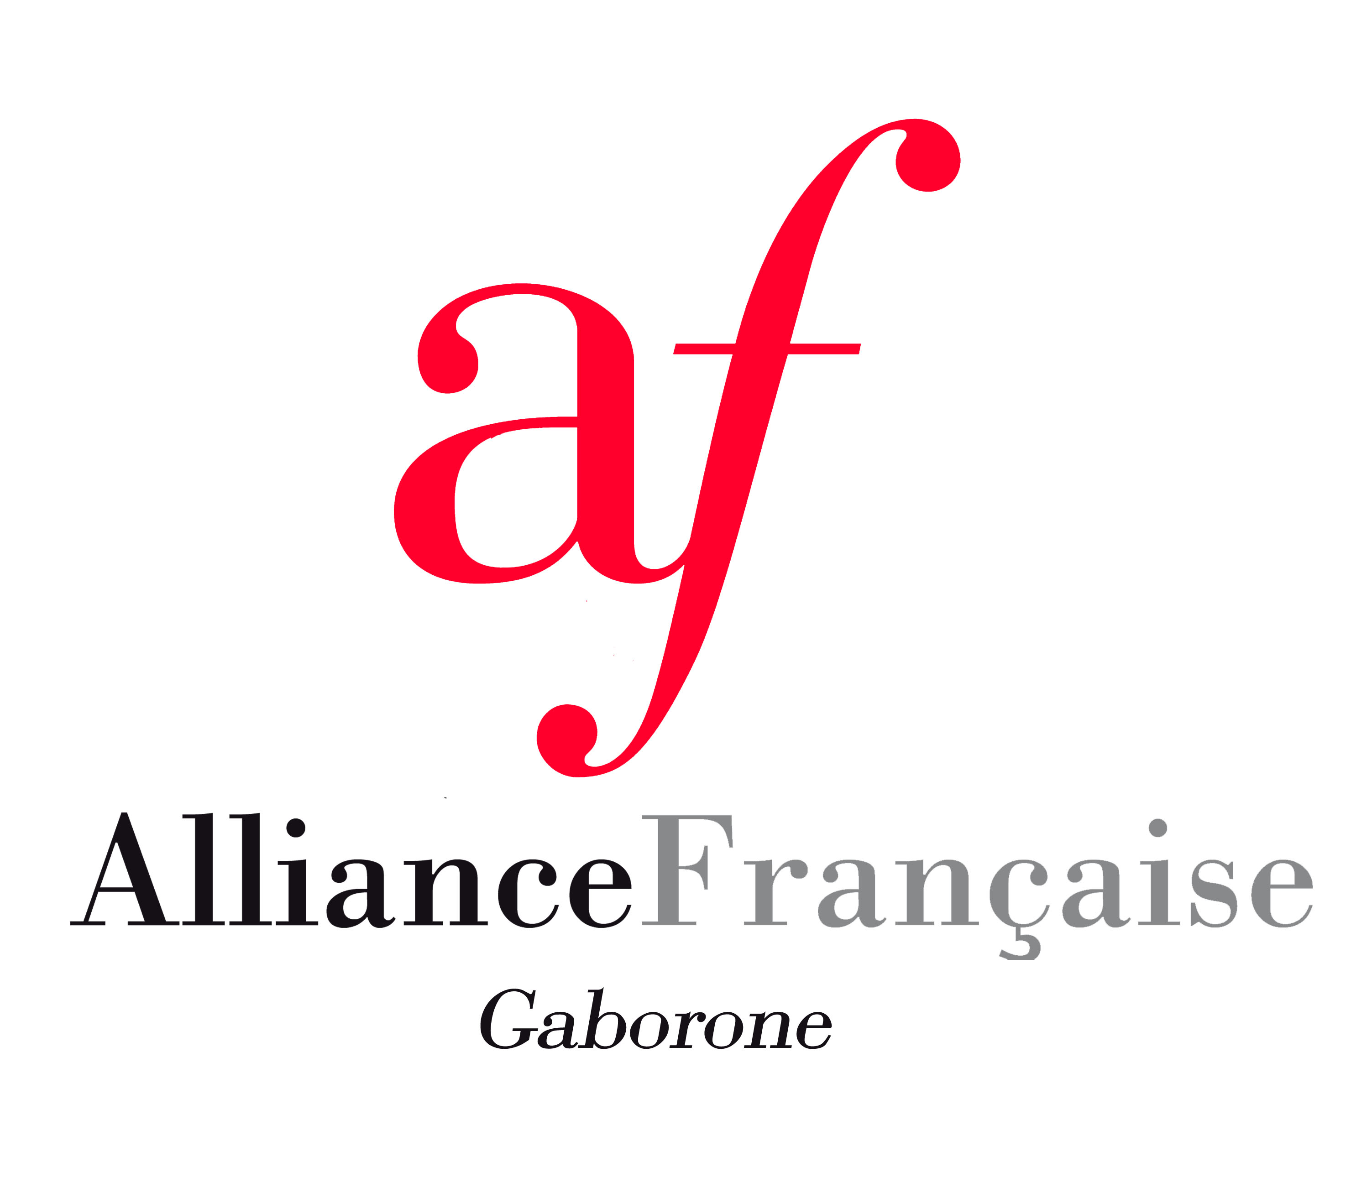
Pays : Botswana Lieu d’inscription : Alliance Française Gaborone
Session N° ………………….. Année ………………..
[Please fill in the form in CAPITAL LETTERS]
Miss Mrs Mr
Surname: …………………………………………………..……………………………..
Name: ……………………………………………………………….…………………....
Date of Birth: ……………………………………………………………..……………..
Place of birth: …………………………………………………………………...……….
Country of birth: ………………………………………………………………………...
Nationality: ………………………………………………………………………………
Mother tongue……………………………………………………………………………
Postal Address: ……………………………………………………………………………
Phone number(s): ………………………………………………………………………..
Email address: …………………………………………………………………………...
Registration for level: A1 A2 (P 750)

B1 B2 (P 800) C1 C2 (P 850)
Have you ever written the DELF examination? If yes, what is your registration number?.........................................................

Droits d’inscription:……………… BWP Réglé le : ….. /……./…… Reçu n° : ……….……
Numéro d’inscription : _____________________

Please note that there is no reimbursement once payment has been done.

